Ross Lewis, Stuart Canning, Jack Patterson, Matthew Spratt

40244063, 40244065, 40267457 , 40240205

CSC2045 – sEMESTER 2 WEEK 11 – THE SYSTEM, FINAL PDF REPORT AND THE PROCESS

# 

# Design Documentation

## Documented Interface Design

**Navigation bar**

This screenshot shows the navigation bar of the festival website. This navigation bar is made available on all the web pages. This interface is designed in a way to allow a user to successfully navigate through the website at ease. From here, the user can navigate to the home page, shows, venue and login page.

**Footer**

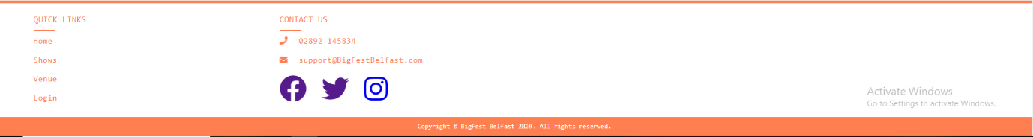

This screenshot shows the footer of the festival website. This footer is also seen across all the web pages. This is designed in a way to allow the user to quickly navigate to different sections of the website and be redirected to external social media platforms which they can use to find out more information on the festival

**Home Page**

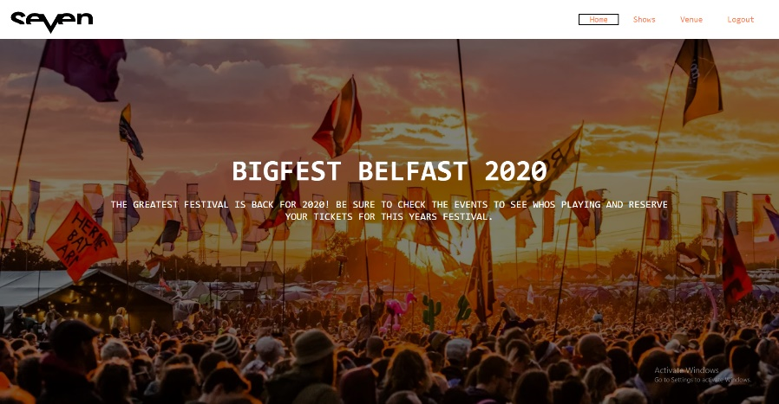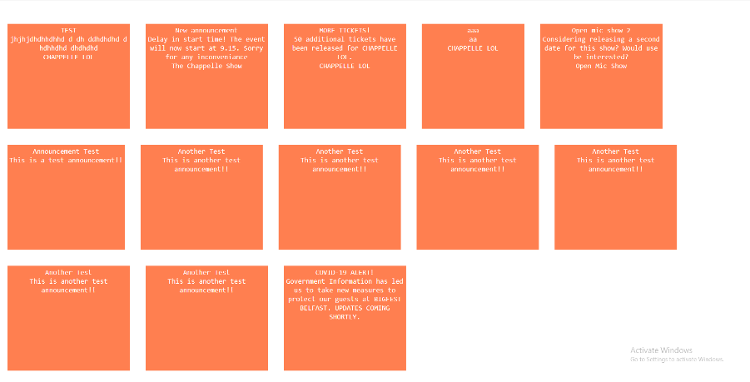

The homepage is the centre of navigation around the website. Any user is able to navigate to the shows, venue or login page. The user is also presented with announcements about shows and venues on this page.

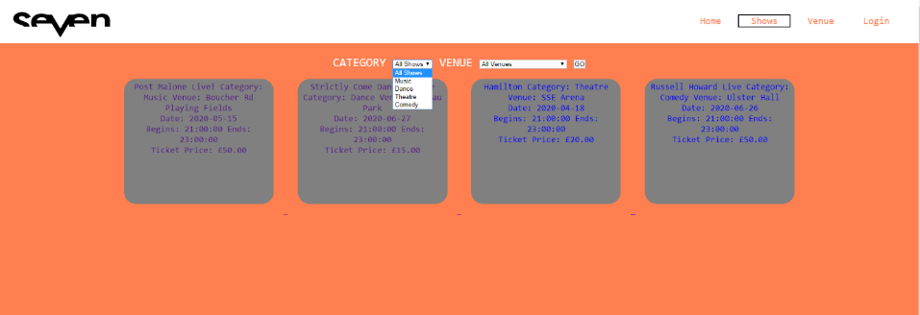**Shows Page**

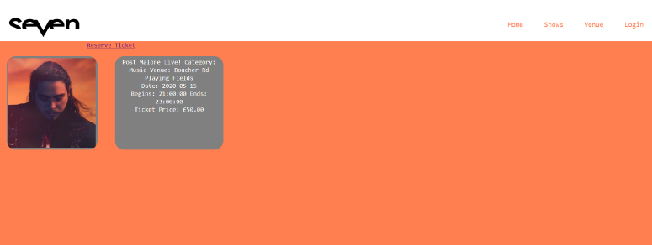The above screenshot is of the shows page on the website. This interface is designed in a way to allow the user to see clearly what shows are on. Drop down menus are available for the user to find a specific type of show or venue. Each of these shows presented can be clicked on where the user is redirected to more information and able to book tickets for that specific show.

This screenshot shows the interface when the user clicks on one of the shows. From here the user can navigate back to the original page or reserve a ticket for this show.

**Venues Page**

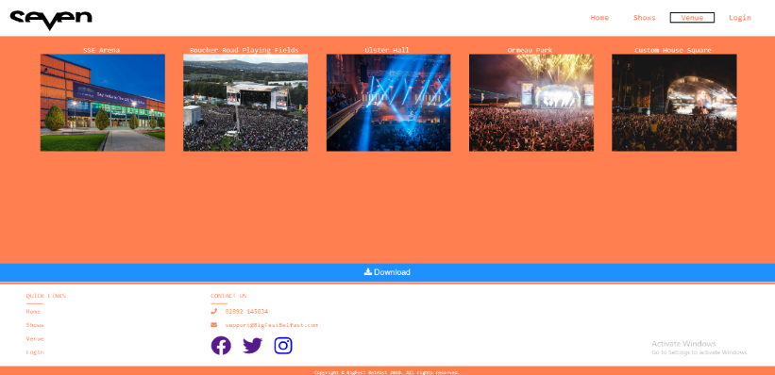This screenshot shows the interface design of the venue page. This is designed in a way to allow the user and performers to see what venues are available.

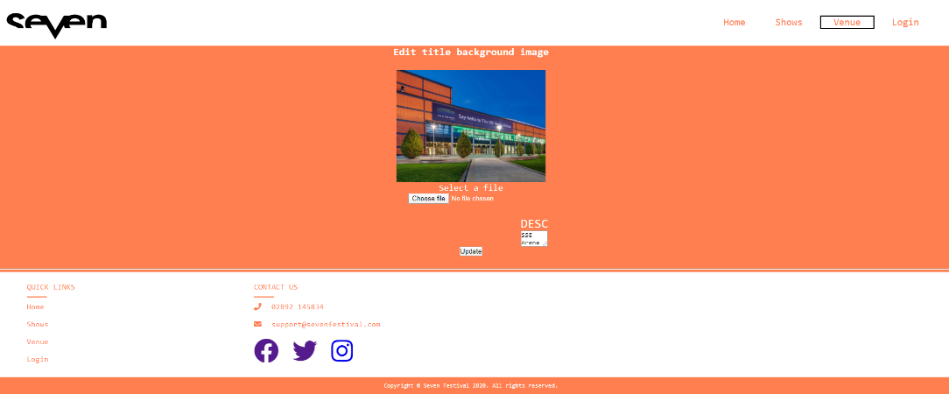

The above screenshot shows the interface design whenever a venue manager is editing a venue. This is designed in a way to be as simple as possible for the user as they can select a new image, give it a new text description and save the changes. This design makes it easy for the user to use the interface.

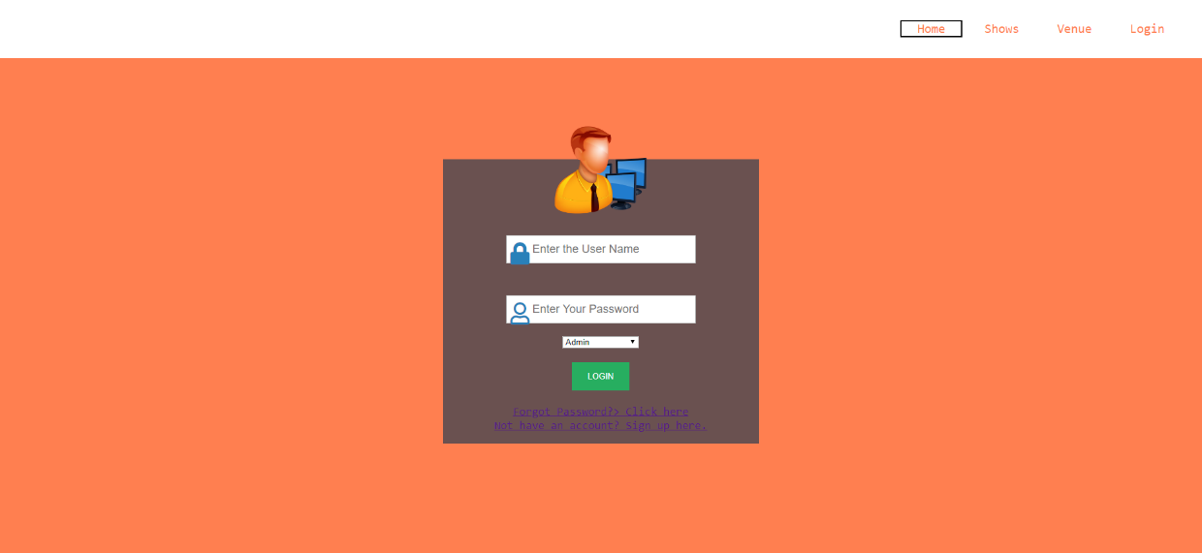**Login Page**

The above screenshot shows the design for the login page interface. This simple design makes it easy for the user to login by entering their username, password and select their user type from the drop-down menu. The user is also able to redirect to the registration page if they don’t have an account through one click. This design also allows the user to easily redirect to a forget password page if they can’t login to their account.

**Registration Page**

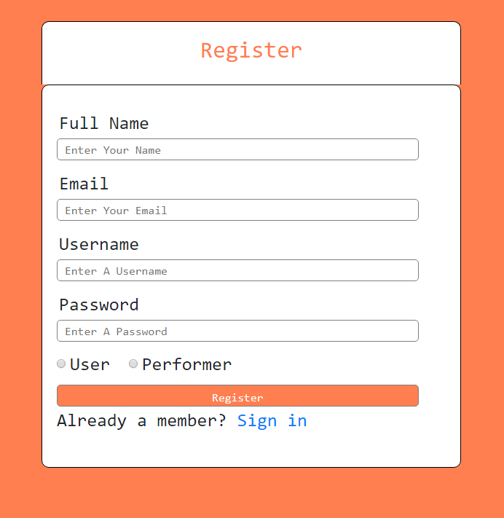

This is a screenshot of the user interface design of the registration page. This makes it as easy as possible for the user to register onto the website by following this form. After inserting all information and clicking register, the user is prompted with a success message where they can then redirect to the login page. This design makes it as easy as possible for a user to register onto the website.

**Forget Password Page**

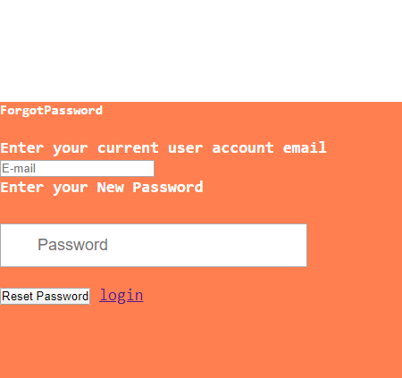The forget password page allows the user to enter the email linked to their account and insert a new password to login with. After doing so, the user can redirect back to the login page and use these new details to access the website.

**Reviews Page**

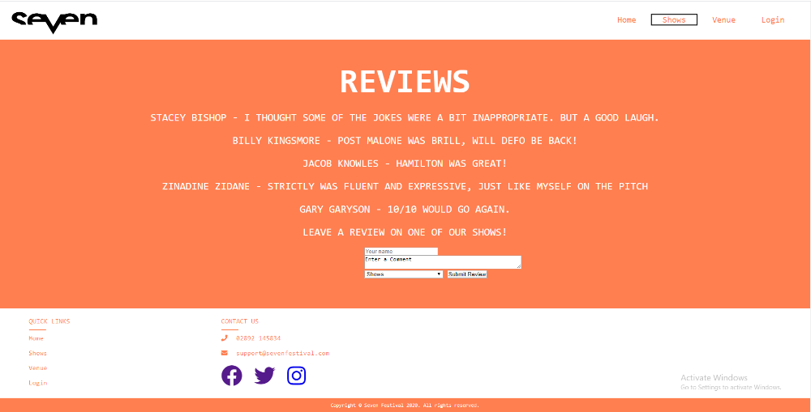The reviews page allows users to leave a review on a specific show whenever they’re logged in. Other users’ reviews can be viewed by all users. The form at the bottom makes it simple for the user to submit their review by inserting their name, comment and selecting which show they attended.

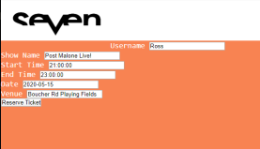**Booking Page**

The booking page makes it very easy for a user to reserve a ticket. After clicking a specific show when logged in, the form autofill’s with the username. This allows a user to easily reserve a ticket for the show which is then stored on the database.

**Admin Panel**

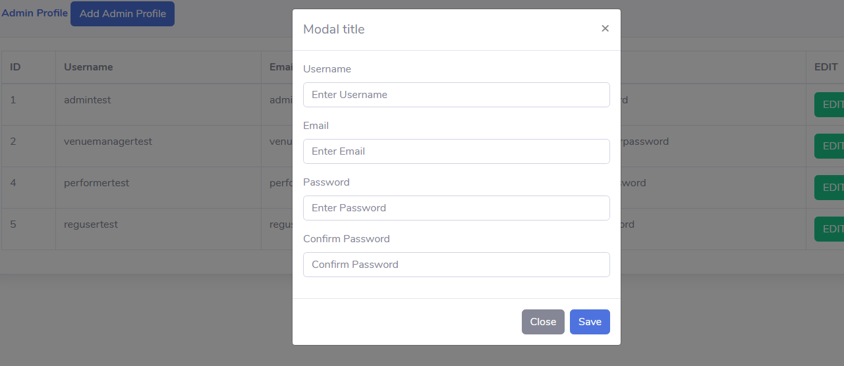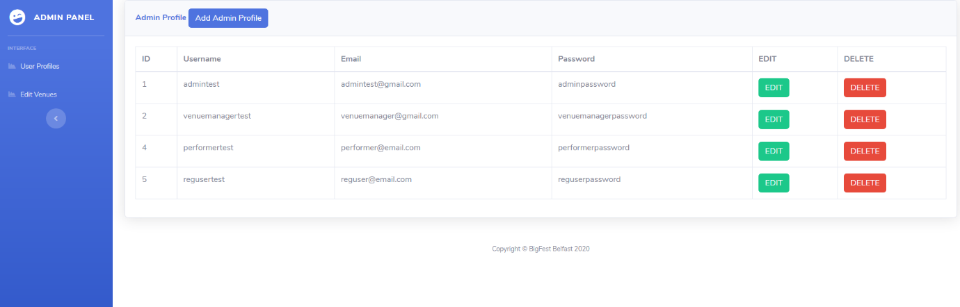This screenshot shows the admin panel. The admin is redirected to this page upon logging in. This interface is designed in a way to make it as easy as possible for the admin to see the high-level user details and edit/delete these users where necessary. The admin is also able to add new profiles through the add profile button located at the top of the admin panel. This simple layout makes it as easy as possible for the admin.

This is the simple interface design of the adding a profile section on the admin panel. This makes it easy for the admin to add a new account by filling out the form.

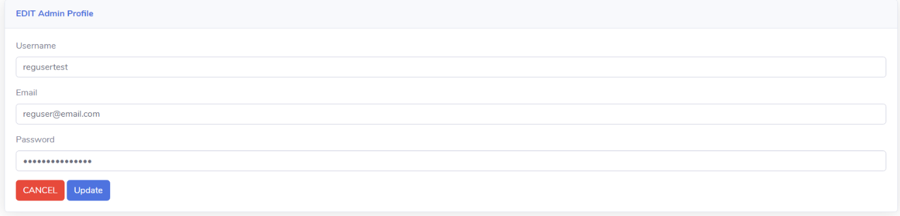This interface is designed to make it as easy as possible for the admin to easily update a profile. From here the admin can change the username, email and enforce password changes. This design makes it easy for the admin to save these changes to the database and update user profiles.

**Venue Manager Profile**

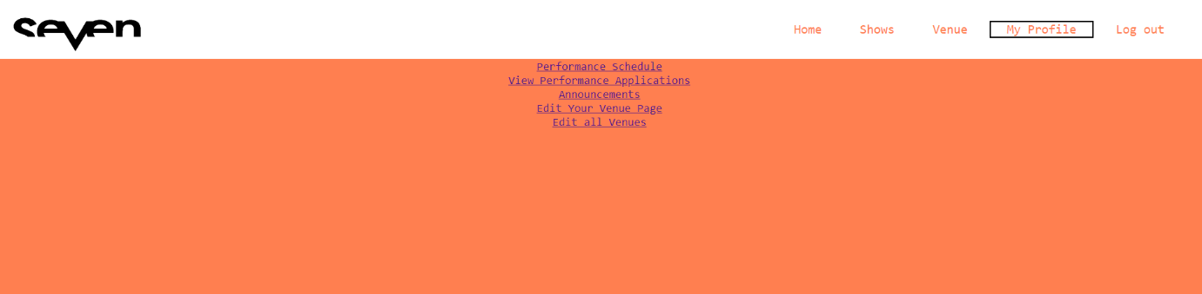The venue manager is designed in a way to allow the venue manager to easily navigate around their venue details by looking at schedules of the venue, applications and the editing of the venue’s details. The href tags make it easy for the venue manager to navigate to these pages. When logged in, the profile of the user that logged in is displayed to the user.

**Venue Manager Edit Venue Page**

The edit venue page allows the user to insert venue details and upload an image and save the changes. This make it very easy for the manager to edit his specific venue details. The venue that is being edited and displayed to the user is one that the venue manager manages.

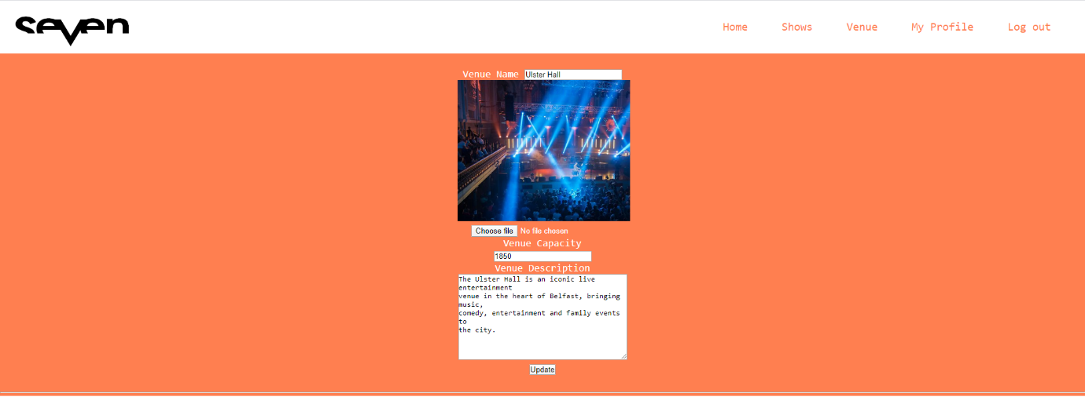**Venue Manager Performance Schedule**

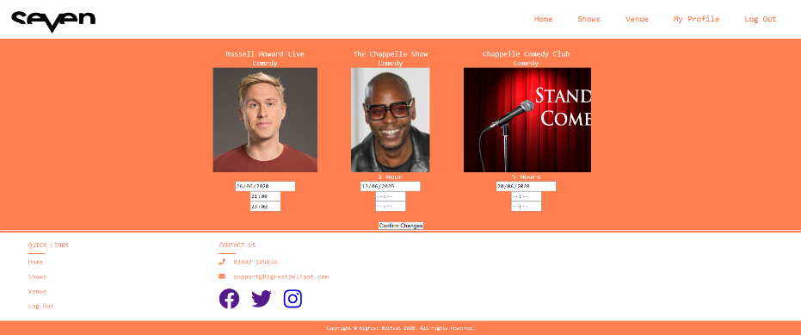

The performance schedule allows the Venue Manager to see when a performer is playing at their venue. From here they can easily adjust the date and time of a specific show.

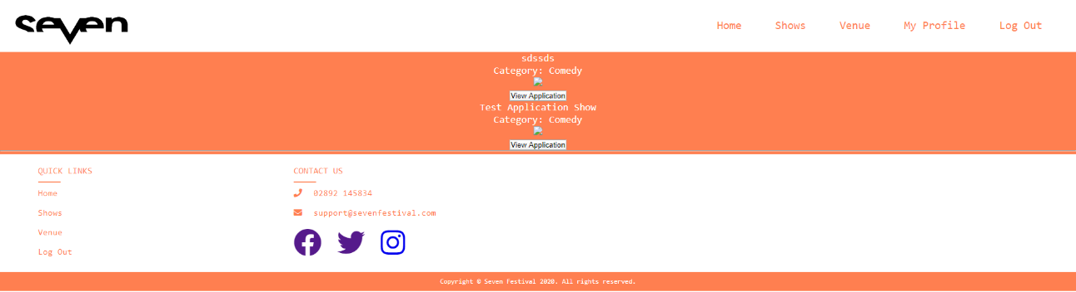

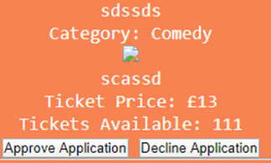The application page allows for a venue manager to see applications for performers to perform at their venue. From here the manager can click into the application, see more details about it and then approve or decline it.

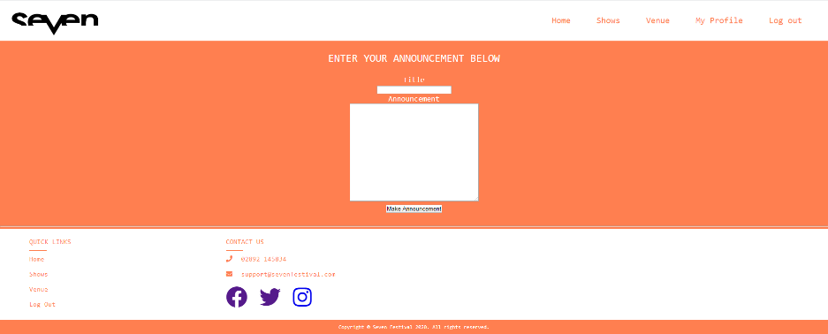

The above image shows the announcements page. The Venue Manager is able to insert a title and text and make the announcement. This is then displayed on the homepage for all users to see. This helps to give information on the managers Venues to all users.

**Performer Venue Application**

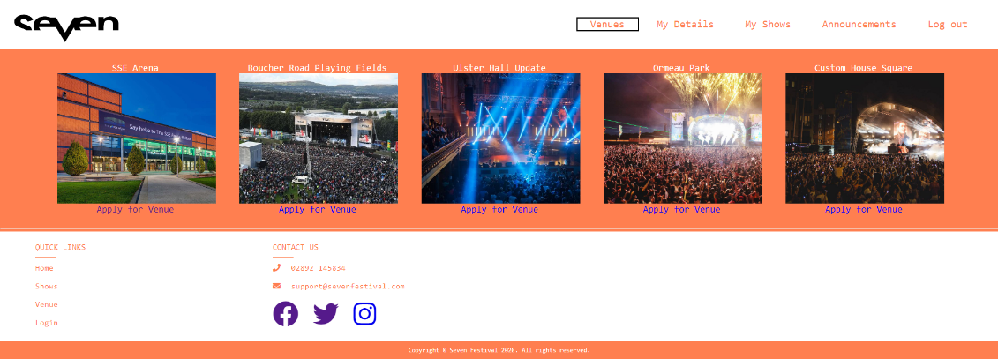After logging in as a perfomer, the venues page allows the user to select a venue that they want to apply to perform at. This is done through a button below each venue which redirects the user to an application form for that specific venue.

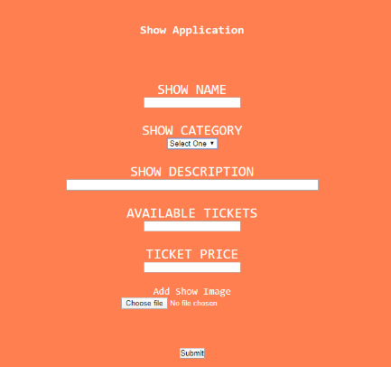

This is the show application that the user must fill out to apply to perform a show at that specific venue. They can select their category from the drop down menu and provide the other details by filling out the form.

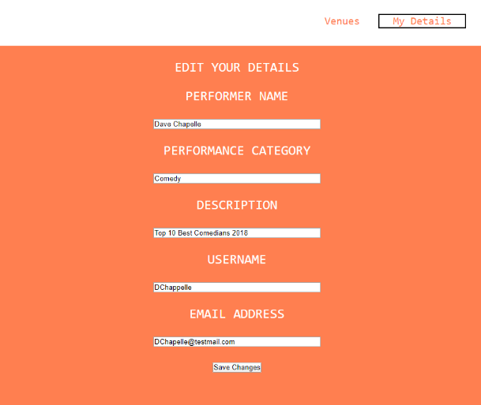

This is the ‘My Details’ page for the performer. This shows the details of the specific performer that has logged in. From here the performer can make any necessary changes required to their details.

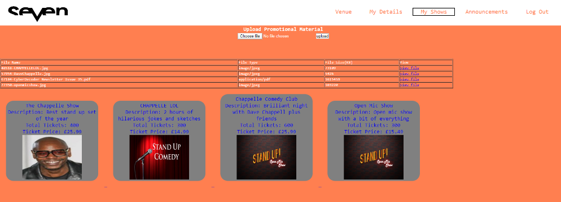

The ‘My shows’ page for the performer shows all the shows that that specific performer has. From here the user can click on the specific show and see information on it such as the ticket price, the amount of available tickets and how many have been reserved.

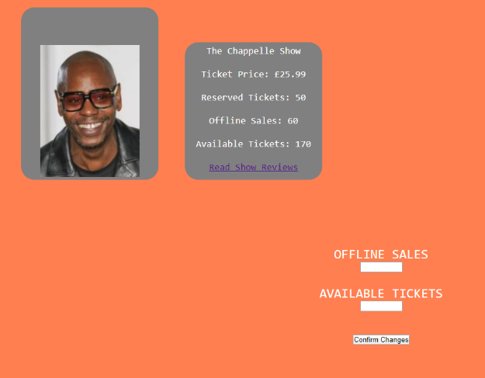This is the design of the specific show. This is where the performer can see how many tickets have been reserved and how many are still available. The performer is also able to go to the reviews section for that specific show and see what reviews users have inputted.

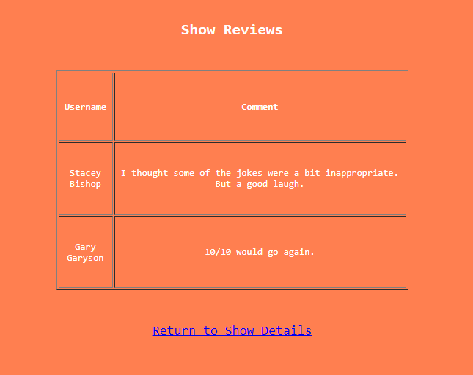

This is the interface design of the shows reviews page. This is designed in a way to make it easy and clear for the user to see the reviews. The shows reviews page allows the performer to see that specific shows reviews.

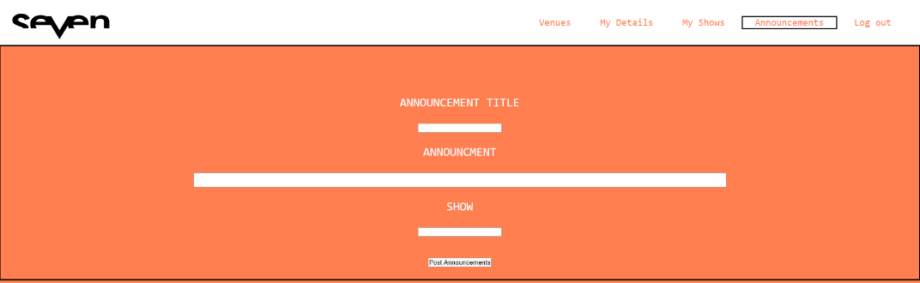

The announcements page has a form which the performer can fill out to give announcements for a specific show that users can view.